Basic Terminology Used by Options Market Makers

Bid: The price someone is willing to pay to buy something.
Eg. Temperature
Expected Temeprature Tommrowi is 64 degree Fahrenheit
Big = 60 degree fahrehanti you egt a 4 degree cushion

Offer: The lowest price at which someone is willing to sell something
Exmaple if expected temp is 64 degree fahrentieit the offer would eb made at 68 which si the lowest price or in thi case the maximum temperature they are willing to bet in thai scenario.

Size - The amount of contact one is willing to trade at a price.

To Make a Market: Provide a Big and ask price and sizes for each

I am 60 bid for 4 and I have 10 at 68

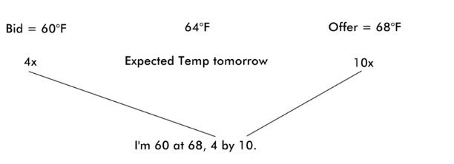

Spread is the difference between bid and ask price
This example spread for the market is 8 degree wide

Hedge: A trade or an investment ot reduce the risk of price momentum in an asset.
Example $100 bet for Chiacgo Bulls to win tonight
Bulls will score less than 120 points tonight
Bulls shoot less than 30 percent 3 points

Paper: Interested parties against Akuna(or other market makers) - pertains to trading
- Orders from intrsetdd parties are gonn a be written on paper by brokers and walked into the pitt
- Gneric term traders use to define people they are trading against

Broker: A person or company that acts as an intermediary between buyers and sellers

Tick Size
- Smallest increment between one price and the next highest or lowest price
Stock xyz 100
Next highest is 100.01 then tick size is 0.01

Queue Priority: A structure used to determine the right of precedence between those in the list
Common method but varies company to company Price time priority method
Akuna organsies by price then then whichiver price level bid was made first regardless of the number of contracts pr the size the time takes precedence over number of contracts but price of the contract takes precedence over time and they organsie it such that the same porice level bid just has the tortola number of contracts and not the split ups
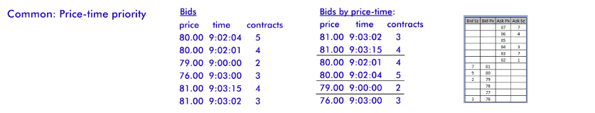
Order Types:
1. Immediate or Cancel order
A type of order that requires all or part of the order to be executed immediately. Unfilled parts of the order are canceled.
Eg. 100 bid for 24 contracts
100 = price
24 = size

If there is an ioc order to sell 50 at 100 quantity followed by price. Normal statement has price first then quantity and then the ioc order has quantity then price so then we sell 24 at 100 and the remain 26 is canceled.

2. Good For Day Order: a type of order that will emain active until executed(in part or full) or until the end of the trading day. Then calcled.

3. Good Til Canceled: A type of order that will remain active until compled or cancleled.

4. All or None: An order type that must be executed in its entirety or not at all.
Eg. 1000 options but only gets filled on 5 more trouble than the worth this is all or none order.

5. Fill or Kill order: An order typoe that must be execuyted immediately in its entirety otherwise its cacelled. (Few seconds, floor trading) Definition it upo for interpretation as traders cna also partially comeltel orders in this scenarios

Fill and Kill order = IOC

One canceles the other (OCO)
When one order or market is exeicueted the other order is automatically cancelled. Protect someone from tartidng multiple markets or orders at the same time and gaining too much epxosure in one direction. Better to disovl4 market in scenarios liek this


